UMD!
Owner/Pet SWOT Analysis

Rate the following:
1. I enjoy the time I spend training my dog.

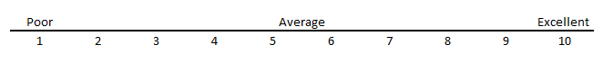

2. Training my dog is a chore.

3. I am always consistent with my1 dog and never give a 1/2 effort.

4. I think my dog should be perfect in how it behaves.

5. I give my dog a lot of attention and affection.

6. I believe I will get out of my dog what I give.

7. I am patient with my dog.

8. I care about my dog's health and nutrition.

9. I have made a lifetime commitment to my dog.

10. I have my dog on a schedule I like.

11. My dog controls my/our schedule.

12. I know my dogs body language.

13. I always wonder what my dog is thinking.

14. I am a strong leader when it comes to my dog.

15. I understand that I have to dominate my dog to train it.

16. I can't socialise my dog until it acts right.

17. I make and stick to the House Rules for my dog.

18. I know everything about my breed's habits and behaviors.

19. My dog always darts after other animals.

20. I always see those other animals first.
Please Describe the following:

Strengths:

Weaknesses:

Opportunities:

Threats:

